TECHNICAL REPORT ON STUDENT INDUSTRIAL WORK EXPERIENCE SCHEME (SIWES)

AT

UPPER TECH HOME OF LUXURY,
MAITAMA, ABUJA

FROM: 6TH OCTOBER, 2024
TO: 29TH JANUARY, 2025

TITLE PAGE

BY

ADAM AHMAD
(SE/ARC/ND/22/075)

DEPARTMENT OF ARCHITECTURAL TECHNOLOGY, FEDERAL POLYTECHNIC MUBI, IN PARTIAL FULFILLMENT OF THE REQUIREMENT FOR THE AWARD OF NATIONAL DIPLOMA (ND) IN ARCHITECTURAL TECHNOLOGY

APRIL, 2025

DECLARATION
This is to declare that I, ADAM AHMAD with registration number SE/ARC/ND/22/075 undertook my four months SIWES at UPPER TECH HOME OF LUXURY, MAITAMA ABUJA and have acquired all the experience compiled in this report in the course of my SIWES.

……………………………….. ……………………………
ADAM AHMAD Sign/Date

CERTIFICATION
This is to certify that this report compiled by ADAM AHMAD (SE/ARC/ND/22/075) meets the requirements governing the award of National Diploma (ND) of the Federal Polytechnic Mubi, and is approved by:

………………………………. …………………………
Name of Supervisor Date
Departmental Supervisor

………………………………. …………………………
Arc. Daniel Barka Date
Departmental SIWES Coordinator

…………………………………. …………………………
Arc. Usman Mohammed Date
Head of Department

DEDICATION
I dedicate this technical report to my parents, my sisters and colleagues and to all those that supported me throughout my industrial training.

ACKNOWLEDGEMENTS
First of all, my sincere appreciation goes to Almighty God and salutation to my prophet.
I wish to thank all staff of Architectural Technology Department in Federal Polytechnic, Mubi.
My appreciation goes to my beloved parent for the motivation, prayers and financial support towards my SIWES exercise.
My special thanks go to my beloved brothers and sisters for all their care and support throughout my industrial training.
I want to also thank my colleagues and others; I really appreciate your efforts.

TABLE OF CONTENTS
TITLE PAGE i
DECLARATION ii
CERTIFICATION iii
DEDICATION iv
ACKNOWLEDGEMENTS v
TABLE OF CONTENTS vi
ABSTRACT viii
CHAPTER ONE 1
INTRODUCTION 1
1.1 Aim of SIWES 1
1.2 Objectives of SIWES 1
1.3 Brief history of SIWES and ITF in Nigeria 2
1.3 Significance of SIWES to students 2
CHAPTER TWO 3
2.1 Brief history of uppertec homes and luxury 3
2.2 Organizational chart 3
CHAPTER THREE 4
DESCRIPTION OF WORK EXPERIENCE 4
3.1 Site clearance 4
3.2 Setting out using surveyor instrument 4
3.3 Excavation of foundation 5
3.4 Filling with sand and watering 6
3.5 DPC and DPM fixing 7
3.6 Setting of pillars and column base 8
3.7 Block work 9
CHAPTER FOUR 11
SUMMARY, CONCLUSION AND RECOMMENDATIONS 11
4.1 Problems observed during the programme 11
4.2 Summary 11
4.3 Conclusion 12
4.4 Recommendations 12
REFERENCES 13

ABSTRACT
The report summarises the result of work done during my SIWES experience, the technical report consists of four chapters, which comprises of introduction, history and criteria’s of SIWES in chapter one followed by their aims and objectives, historical background, organizational structure of the organization in chapter two, while chapter three consist of Site Clearance, Setting out using surveyor instrument, Excavation of foundation, Filling with sand and watering, DPC and DPM fixing, Setting of pillars and column base , and block work the work actually carried out during the SIWES programme and lastly chapter four consist of the summary, Conclusions and Recommendations.

CHAPTER ONE

1.0 INTRODUCTION
SIWES meaning “Student Industrial Work Experience Scheme” is a skill training designed to expose and prepare student in institution of higher for industrial working situation they may likely meet after graduation. The scheme is meant to train student on the method of work and the experience needed in handling the equipment and machines may not to be available in their institution. The scheme is financed by the Federal Government and operators through Industrial Training Fund (ITF), Ogwo, (2001) and operates with National University Commission (NUC), National Board of Technical Education (NBTE), and National Commission for College of Education (NCCE) and industries. However, SIWES also expose the student to many practical works which the institution did not treat in details without plastering what the institution taught theoretically into practical. A point from academic obtained. SIWES assist the student to understand the nature of his/her work in future.

1.1 Aim of SIWES
The aim of this Student Industrial Work Experience Scheme (SIWES) is to expose the students to work experience and practicals.

1.2 Objectives of SIWES
- It helps the students to gain work experience during the Student Industrial Work Experience Scheme (SIWES).
- To identify proper work experience on Architectural designs and working drawing during Student Industrial Work Experience Scheme (SIWES).
- To study and adopt Architectural design during the Student Industrial Work Experience Scheme (SIWES) etc.

1.3 Brief history of SIWES and ITF in Nigeria
It was said by Dr. Azikiwe Nnamdi, the one president of Nigeria that the practice of work but they all have the same goal that they all want to achieve in countries like china. They established within the premises of institution to provide real life situation, lack of practical skill of locally trained engineers and technologies. the chine way and condition of SIWES is that all institution must give student real life working experience in industrial works. Lecturers are involved in the industrial activities rendering constant services. So, all these countries have their own way of conducting the scheme but all lye on the same goal. And in Nigeria, the history of SIWES can be traced by the history of IITF which is the backbone of SIWES. ITF was established in 1974 under degree of 47 of 1971 (Edward, 2003). It was a body established by the Federal Government of Nigeria and was given responsibility of training indigenous Nigerians. The establishment of the body became necessary due to high demand of Nigeria to take up the vacant positions created in various sector of the economy after the colonial masters have departed. Therefore, the Federal Government discovered that it is easier to train students that are skilled in school to be trained and meet up with gaps in the Nigerian economy and a scheme was established to care for such training and it was named Student Industrial Work Experience Scheme (SIWES). In 1973, the National Board of Technical Education (NBTE) made it compulsory for all the polytechnic students, be it federal or state (Francis, 2012).

1.3 Significance of SIWES to students
Principles taught in the classroom are vein forced given concrete applications on the industrial assignment and students is able to see the relevance of their students which increase their motivation. It helps in given students the knowledge on the types of work to do after his/her graduation. SIWES given students opportunity for a change of environment as they move their institution to the place of attachment which changes the routine types of environment to a word of work. It helps in connecting the institution and the industrial their relationship the introduction of SIWES.

CHAPTER TWO

2.1 BRIEF HISTORY OF UPPERTEC HOMES AND LUXURY
Uppertec Homes and Luxury Limited is a registered limited liability company in Nigeria, established to redefine the real estate experience through a unique blend of luxury, affordability, and customer satisfaction. Headquartered in Abuja, the company has rapidly grown to become one of the leading players in the realty sector, distinguished by its commitment to delivering high-quality residential and commercial developments. From its inception, Uppertec has been driven by a vision to design and construct modern estates that not only meet the highest standards of quality but are also delivered on schedule. The company is managed by a team of seasoned professionals who are dedicated to upholding excellence in every project. Their consistent adherence to quality, timely delivery, and customer-centric values has earned Uppertec a solid reputation within the construction industry.

2.2 ORGANIZATIONAL CHART
CHAIRMAN
MANAGING DIRECTOR
PROJECT MANAGER
CIVIL ENGINEER

BUILDING ENGINEER

SITE MANAGER
HUMAN RESOURCE
LABOURERS

STUDENTS
ACCOUNTANT
ADMINISTRATORS

Figure 2.1: Organogram

CHAPTER THREE

3.0 DESCRIPTION OF WORK EXPERIENCE

3.1 SITE CLEARANCE
Before the excavation of the proposed foundation commences, we cleared the site. So therefore, site clearance is the removal of all accumulated waste from an area to ensure that it is free from any environmental hazard, obstacle or unsightly mess.

3.2 SETTING OUT USING SURVEYOR INSTRUMENT
During the course of the project, I participated in setting out the building using a surveyor’s instrument, specifically a total station. This method allowed us to achieve a high level of accuracy when marking out the building layout on site. We began by establishing permanent reference points and benchmarks, which served as the basis for transferring the design onto the ground.
Using the total station, we carefully measured and marked the building's lines, ensuring all corners were properly aligned and formed accurate right angles. We also checked the diagonals to confirm the squareness of the structure. Unlike manual methods, this approach reduced the chances of errors and ensured that every measurement matched the building’s plan.
I observed how the instrument allowed us to work efficiently, especially over longer distances where manual methods might have failed. The site engineer emphasized the importance of accuracy during this stage, noting that any mistake in setting out could affect the entire structure. Overall, setting out with the surveyor’s instrument helped us maintain precision and contributed significantly to the durability of the building.
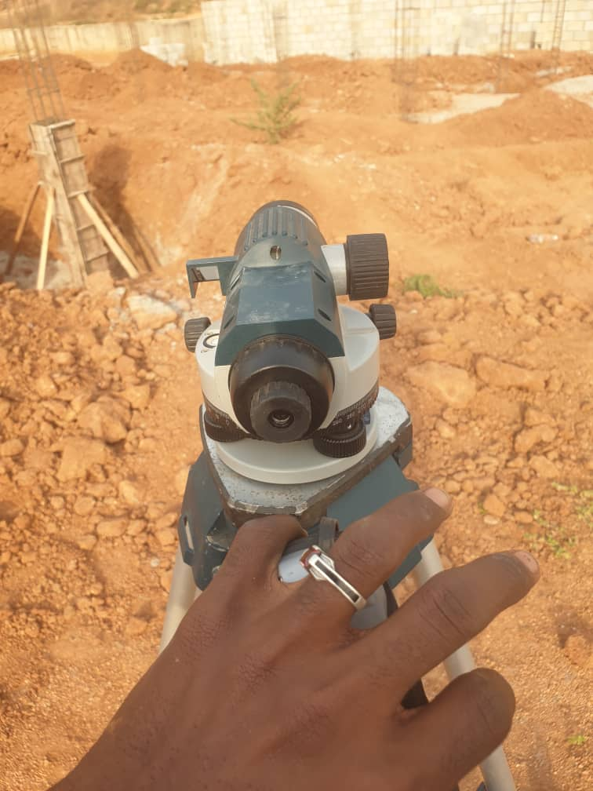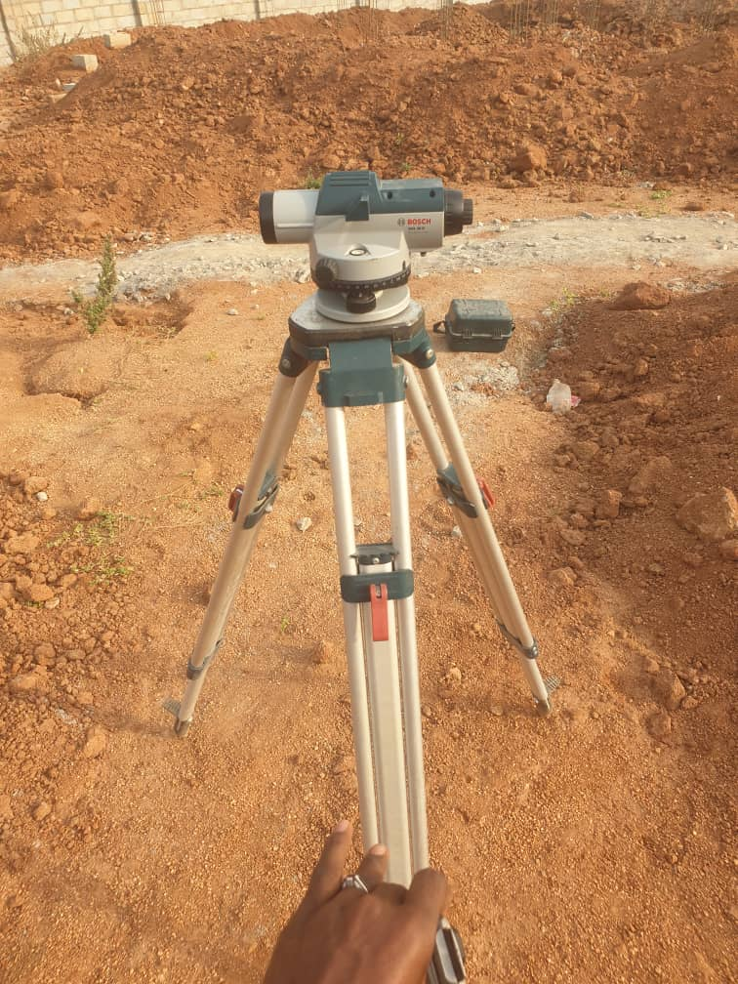
Plate 3.1: Setting out using Surveyor
Source: Author’s work, 2024

3.3 EXCAVATION OF FOUNDATION
Excavation was carried out as the first major step in the construction process to prepare trenches and holes for pile and strip foundations. The work involved both manual and mechanical methods, depending on the size of the area and the nature of the soil. Key factors considered included soil type, foundation depth, climatic conditions, water table level, and the impact on nearby structures. Strip foundations involved digging continuous trenches, while pile foundations required deeper, square-shaped holes (ranging from 1.2m x 1.2m to 1.4m x 1.4m).
In weak soil areas, a mixture of cement and sharp sand was applied at the base before placing reinforcement baskets to prevent rusting. The entire process was carefully monitored by the site engineer and foreman to ensure accuracy, safety, and structural integrity. Overall, the excavation works were successfully completed with strict adherence to standards, ensuring a solid foundation base for the construction project.

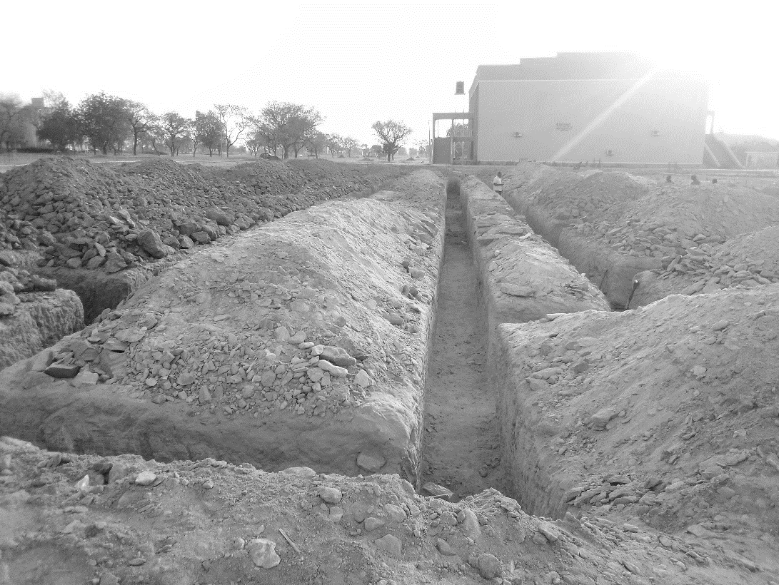

Plate 3.2: Foundation
Source: Author’s work, 2024

3.4 FILLING WITH SAND AND WATERING
After the excavation and reinforcement works were completed, I took part in the process of filling the foundation with sand. This step was essential to provide a firm base and to support the foundation structure. We used sharp, clean sand to fill the gaps around the reinforcement and within the excavated trenches.
The sand was poured in layers, and after each layer, we compacted it manually using rammers to reduce air pockets and ensure proper settlement. Once the filling was done, we proceeded to water the sand thoroughly. This watering process helped to increase compaction and stabilize the soil, reducing the chances of future settlement or foundation cracks.
I noticed that watering the sand also helped in binding the particles together, making the filled foundation trench more solid. The site supervisor emphasized that this step was important in achieving long-term structural stability. Overall, the combined process of sand filling and watering played a key role in preparing the foundation for concrete work and ultimately contributed to the durability of the entire building.

3.5 DPC AND DPM FIXING
Following the completion of foundation filling and compaction, I was involved in the installation of the Damp Proof Course (DPC) and Damp-Proof Membrane (DPM) to prevent moisture from rising into the building structure.
The DPC, which is typically a layer of waterproof material (such as thick plastic sheeting or bituminous felt), was laid horizontally on top of the blockwork at the base of the walls. This layer served as a barrier to stop ground moisture from seeping upward into the walls, which could otherwise lead to dampness and long-term damage. We made sure that the surface was clean and level before placing the DPC to ensure full coverage and effectiveness.
Right after laying the DPM, we also applied the Damp Proof Course (DPC) over the compacted sand and hardcore surface of the floor area. The DPM, which is a durable polythene sheet, was carefully spread out across the foundation floor and extended slightly up the sides to overlap with the DPC. This was done to create a continuous moisture barrier. We ensured there were no punctures or tears, and where necessary, joints were overlapped and sealed with waterproof tape.
The engineer on site emphasized the importance of both DPC and DPM in preventing moisture ingress, which could lead to mold, deterioration of materials, and an unhealthy living environment. Being part of this process gave me a better understanding of how critical these protective layers are in maintaining the integrity and lifespan of a building.
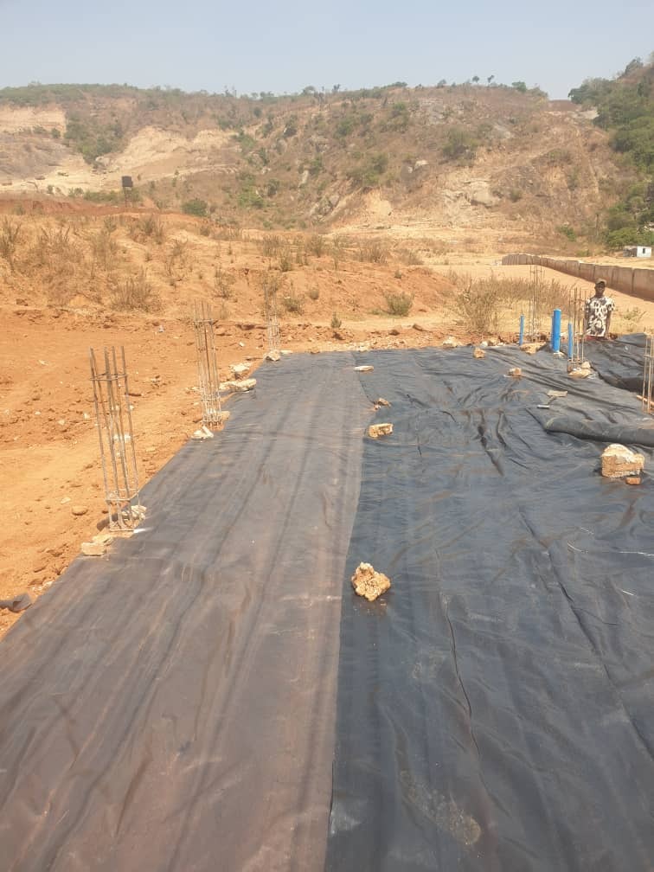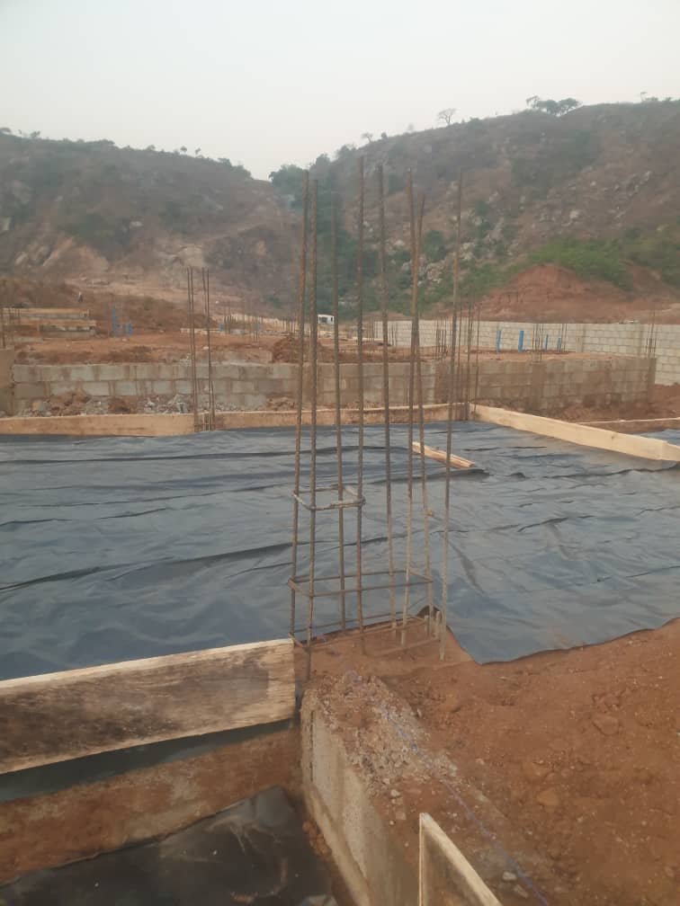
Plate 3.3: Tiled surface of the floor
Source: Author’s work, 2024

3.6 SETTING OF PILLARS AND COLUMN BASE
During the construction phase, I was actively involved in the setting of pillars and column bases, which formed a crucial part of the structural framework of the building. This process started immediately after the completion of the foundation and damp proofing works. The engineer and foreman first identified and marked the exact positions where each pillar (column) was to be located, based on the structural drawings. Using measuring tapes and lines, the layout was carefully transferred from the plan onto the site. Once marked, we began by fixing the column starter bars, which had already been placed during foundation reinforcement. These bars served as the vertical extensions for the column reinforcements. We then assembled and tied the column reinforcement cages using binding wire, ensuring proper spacing with the help of concrete spacers. After this, formwork (shuttering) was installed around the reinforcement to shape the columns and hold the concrete in place. The formwork was aligned and secured firmly to avoid any displacement during casting.
With everything set, we poured concrete into the column bases and formwork, ensuring it was properly compacted using a vibrator to remove air pockets and achieve a solid, uniform structure. The concrete was allowed to cure properly, and we kept the surface wet for several days to strengthen the columns. Setting the pillars and column bases required accuracy, teamwork, and close supervision, as any misalignment could affect the overall stability and aesthetics of the building. I learned the importance of precision and how critical columns are in transferring loads from the building structure down to the foundation.
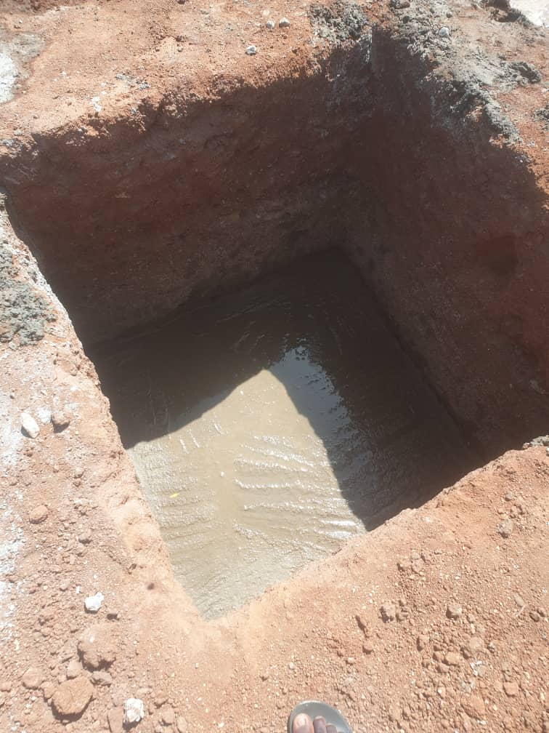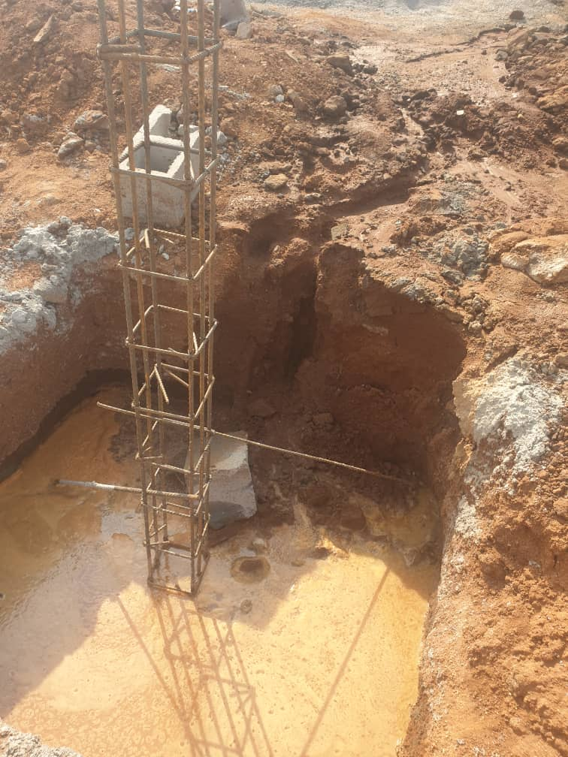
Plate 3.5: Setting of Pillars
Source: Author’s work, 2024

3.7 BLOCK WORK
After the completion of the foundation and the laying of the damp proof course (DPC), we proceeded with the block work up to the DPC level. This stage involved laying concrete blocks to bring the wall height from the foundation up to the level where the floor slab would eventually rest. We began by mixing mortar in the correct ratio of cement to sand, usually 1:4, to ensure strong bonding between the blocks. The first course of blocks was carefully laid along the marked lines using a spirit level and plumb bob to maintain straightness, alignment, and verticality. Extra attention was paid to the corners, which served as guides for other courses. As we built upwards, we continually checked for level and alignment to avoid any leaning or structural inconsistencies. We also allowed space for any openings such as vents or pipe sleeves, as indicated in the building plan. Once we reached the DPC level, we ensured the top of the block work was neatly finished and leveled, ready to receive the concrete floor slab. This phase was critical as it formed the base for all subsequent superstructure work. I also learned that any error at this stage could affect the entire wall alignment above.
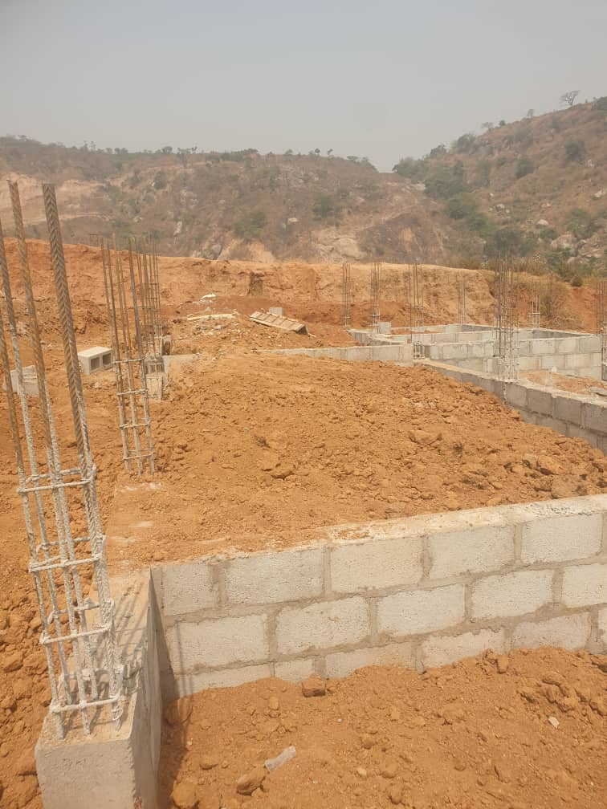
Plate 3.6: Block Work
Source: Author’s work, 2024

CHAPTER FOUR

4.0 SUMMARY, CONCLUSION AND RECOMMENDATIONS

4.1 PROBLEMS OBSERVED DURING THE PROGRAMME
During the course of my SIWES programme, I encountered several challenges that affected the overall learning experience:
- The duration of the programme was relatively short, which made it difficult to complete certain practical aspects thoroughly.
- There was no financial support provided by the company, which made daily transportation to and from the training site burdensome.
- Most of the workers did not offer adequate guidance or mentorship to the IT students. It was largely a self-driven learning environment where students had to ask questions or observe closely to learn anything.

4.2 SUMMARY
The Students Industrial Work Experience Scheme (SIWES) is an important platform designed to train and develop both the mind and body for efficient performance in the professional world. This programme effectively complements classroom-based theoretical learning with hands-on industrial exposure. Through participation in SIWES, students gain a better understanding of real-world industrial processes, including the importance of safety regulations, time management, teamwork, and quality control.
It offered me the opportunity to be actively involved in the daily operations of a professional work environment, thus preparing me for future responsibilities in the construction industry. The experience has broadened my perspective on the practical application of my academic knowledge.
To fully realize the benefits of the programme, it is crucial that input from Industrial Training Fund (ITF) coordinators and institutional supervisors is considered for continuous improvement.

4.3 CONCLUSION
The SIWES programme plays a crucial role in the academic and professional development of students, especially those in technical and engineering fields. It serves as a bridge between theoretical knowledge acquired in the classroom and the practical demands of real-life job environments. Beyond technical skills, it also encourages collaboration among students from various institutions and disciplines, fostering idea-sharing and teamwork.
Participating in the programme has given me firsthand exposure to construction processes, work ethics, and the importance of continuous learning in the field.

4.4 RECOMMENDATIONS
Based on my experience during the SIWES programme, I would like to make the following recommendations:
- Higher institutions should establish strong partnerships with companies and organizations in relevant industries to secure placement opportunities for students. This can also open doors for future employment opportunities.
- Students should approach the SIWES programme with a mindset focused on learning rather than financial gain. While stipends are beneficial, the skills and knowledge acquired are of far greater value in the long run.

REFERENCES
Adeyemi, M. B. (2007). Technical Education and Industrial Development in Nigeria. Journal of Educational Research and Development, 2(1), 45–52.
Chudley, R. (2005). Construction technology volume 2. Pearson Prentice Hall, New York.
Edward, B. (2003). The Effect of SIWES on a student, Federal Ministry of Works, Lagos. Nigeria.
Francis, K. (2012). Building Construction Illustration. (Fourth Edition). Wiley Publisher. ISBN-10: ‎ 9788126535637.
Ofoegbu, F. I. (2009). Industrial Training and National Development in Nigeria: The Role of SIWES. Nigerian Journal of Educational Administration and Planning, 9(2), 115–126.
Olaitan, S. O., Nwachukwu, C. E., Igbo, C. A., Onyemachi, G. A., & Ekong, A. O. (1999). Curriculum Development and Management in Vocational Technical Education. Onitsha: Cape Publishers International.

